**Identity and Access Management(IAM):**

* It provides the Authentication and Authorization to the user.
* IAM gives the login credentials and permissions to access the services in AWS console.
* We can create the users,groups.roles and policies in IAM dashboard.

**Authentication:**

It is nothing but a login id or username and password to login the console.

**Authorization:**

It means provide the permissions to access the services .

**Role:**

* Role is a task which is attached to the service in AWS.
* Role is same as user but main difference is user has fixed credentials like username and password whereas role has temporary credentials.

**Policies:**

Policies are nothing but a permissions (which services are user can access) which are attached to the users or roles or groups.

**Types of Policies:**

* **AWS Managed Policies**
* **Inline Policies**

**AWS Managed policies:**

There multiple aws managed policies are available in IAM .These policies are managed by AWS .

**Inline Policies:**

These are the customer managed policies.

**Steps to create User in IAM:**

* Go to IAM dashboard and click on users.
* Click on create user and enter the name of user.
* While creating user we can select the “provide user access to aws console” option or we can create this access after creation of user.
* Click on next and select the attach policies directly.
* Select the services which we want to give the access to the user in the permissions policies.
* Click on create user.

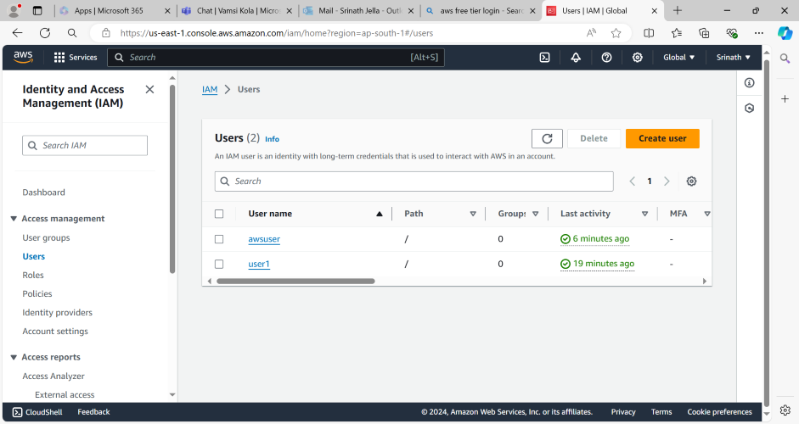

**Log Into the new IAM User:**

* Click on the username and click on security credentials.
* Copy the console sign in link on the browser.
* Enter name of the user and password (custom password).If you are not select a “provide user access to aws console” option while creating user you can recreate the new password while sign in into the console as a iam user.
* Now we can login to the new iam user.

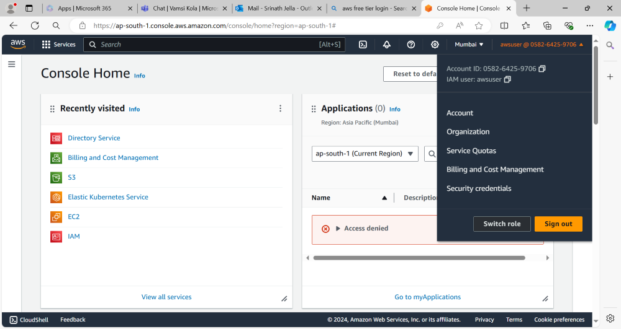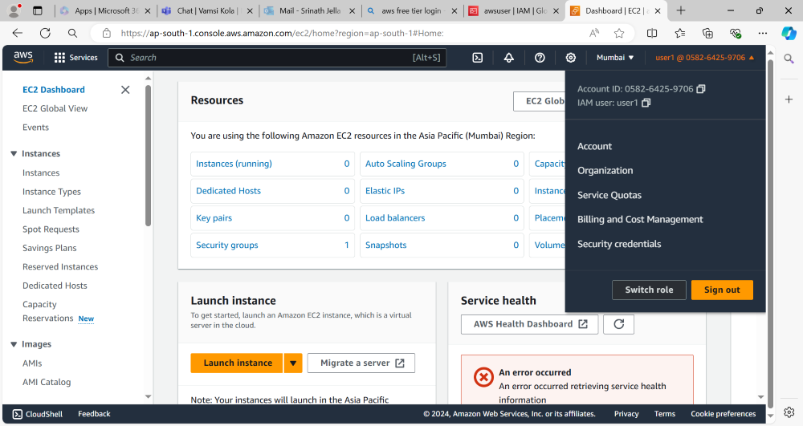

**Steps to create the IAM Role:**

* Click on the roles which is available on iam dashboard.
* Click on create role and select aws service .
* Select the use case or service (To which service we want to add this role).In which I have selected EC2 service.
* Click on next and select the services which services we want to access from above service .(in which I have selected s3 service).
* Enter the name of role and click on create role.

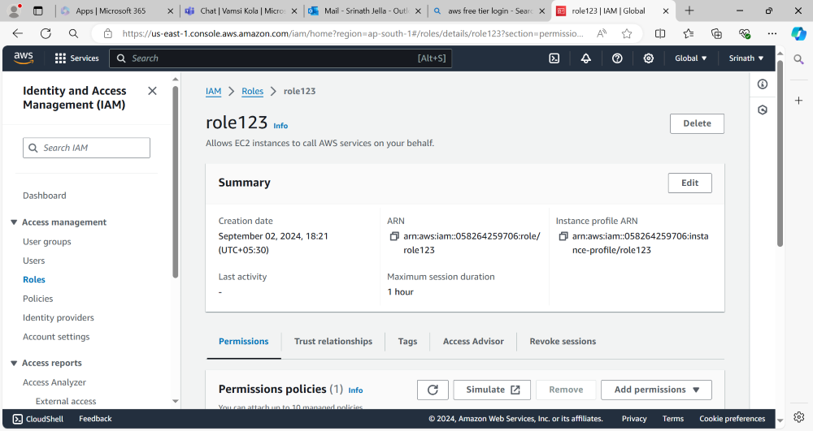

**Groups:**

* Instead of creating and attaching policies to the users individually we can create the group and attach the policies to that group.
* Attach the users to the particular group.
* Users have all the permissions whatever permissions that group has.

**Steps to crete Group:**

* Go IAM dashboard and click on user groups option.
* Click on create group and enter group name whatever we want.
* Add the users to this group or we can add the users to this group after creation of group.
* Attach the policies(to which services we want to give the access to this group) and click on create user group.

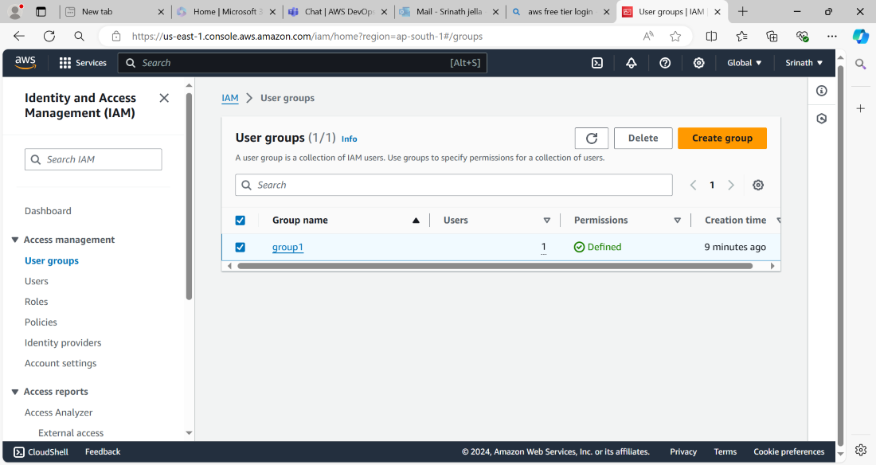

**Login to AWS Console by using programmatic access:**

* From AWS CLI (command line interface) We can able to sign into a AWS console by providing Access key and Secret key.
* We need to use “aws configure” command to provide access key and secret key on AWS CLI.

